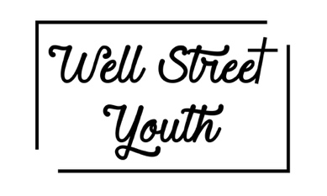

GENERAL PERMISSION FORM
This form must be completed by a parent/guardian in order for the young person to participate in the event/activity.
It should be signed and returned to:
Bev Hamilton

Please note if this form is not competed in full and returned to the person named above the young person may not be able to participate in the event/activity

Full name of the young person ………………………………………………………………………….Date of birth …………………………………..
Address ……………………………………………………………………………………………………………………………….………………………………………
………………………………………………………….………………………………………………………………Postcode……………………..……………………

Emergency contact
Name…………………………………………………………………….. Relationship to the young person…………………………………...……….
Telephone number ……………………………………………
Second Emergency Contact
Name…………………………………………………………………….. Relationship to the young person…………………………………...……….
Telephone number ……………………………………………

Young person’s registered GP
Name …………………………………………………………..……………………………Telephone number ………………..………………………………
Address ……………………………………………………………………………………………………………………………….………………………………………
………………………………………………………….………………………………………………………………Postcode……………………..……………………

Does the young person have any medical conditions which we should be aware of? YES/NO
If yes, please give details…………………………………………………………...………………………………………………………………………………

Does the Young person suffer from any allergies? YES/NO
If yes, please give details…………………………………………………………...………………………………………………………………………………

Declaration
Please note that this declaration can only be signed by those with parental responsibility
I give permission for ……………………………………. to take part in the activities listed below:
Chill’n’Chat | Inferno (Sunday morning)
Coffee Club | Youth Alpha
Explorers (Young Leader) | Soul Survivor Saturday Celebrations

I give permission for my young person to be transported to and from an event by car when appropriate.
In an emergency and/or I cannot be contacted I am willing for my child to receive necessary hospital or dental treatment.
I give permission for photos and videos of my young person to be taken. Please specify below:
I give permission for the photos and videos to be used publicly on the church website, YouTube and Instagram
I give permission for the photos to only be used privately on our closed Facebook and WhatsApp groups
I give permission for my young person to attend meetings and activities on Zoom when appropriate. I am aware that if my Y/P is under 13 then a responsible adult needs to be within earshot during Zoom meetings.
I give permission for Well Street United Church to store this information securely including in electronic format. (Please see Well Street United Church Privacy Policy for data retention information.)
I undertake to inform the leader should any on the above information change

Signed……………………………………………………………………………………………….
Date……………………………………………………………………………

